**Getting the solar, wind, and load data with the following criteria are hard:**

* Same large area, for example CA
* Same time period
* With 5 min time interval

**The facts are:**

* Solar data with 5min time interval of year 2006 is available for entire CA
* Wind data with 10min time interval of year 2004 – 2006 is available, however, the original data set is not available download. Some API is still available but has download file limitation, thus only small area data can be download.
* Historical data is not available tracing back to 2006.

**However, here are some solution that we can apply to temporarily solve the problems:**

* Select the certain small area in CA as the targeted area for both wind and solar in 2006
* Use interpolation algorithm to convert 10min to 5min wind data
* Scale both wind and solar up based on the CA’s renewable portfolio of recent years.
* And perform the analysis with the load in recent years.

**The process**

For the wind power, I selected a small area in CA first, according the wind data API limitation, I choose the area south to Redding, north to Red Bluff, west to red Bluff.

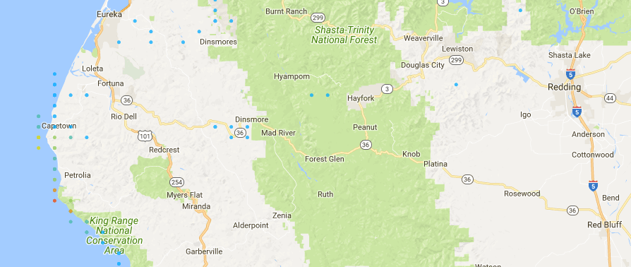

Wind data link: <https://maps.nrel.gov/wind-prospector>

For solar power, I select the similar area.

Redding, CA 🡪 (40.606730, - 122.379555)

Red Bluff, CA 🡪 (40.166566, -122.235196)

Thus, I count the sites (around 40, -inf~ - 122.235196) in CA

Actual (39.75, - 120)

<https://www.nrel.gov/grid/solar-integration-data.html>

For the load, since CAISO don’t have the 5min level load public available.

The results are as follow:

* **Wind**

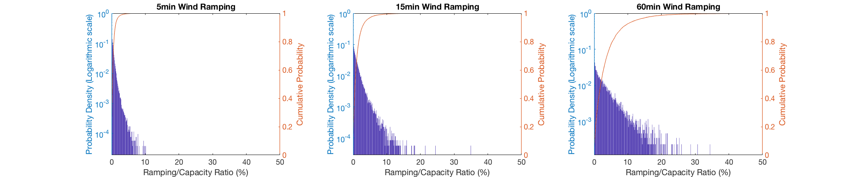

WT5Ramping =

0.0151

WT15Ramping =

0.0402

WT60Ramping =

0.1256

* **Solar**

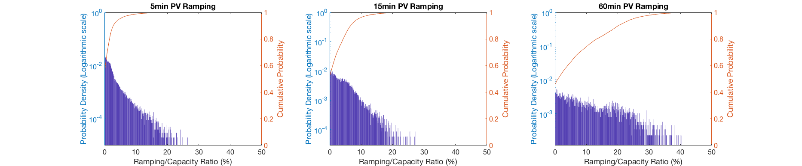

PV5Ramping =

0.0480

PV15Ramping =

0.0901

PV60Ramping =

0.2482

* **Demand**

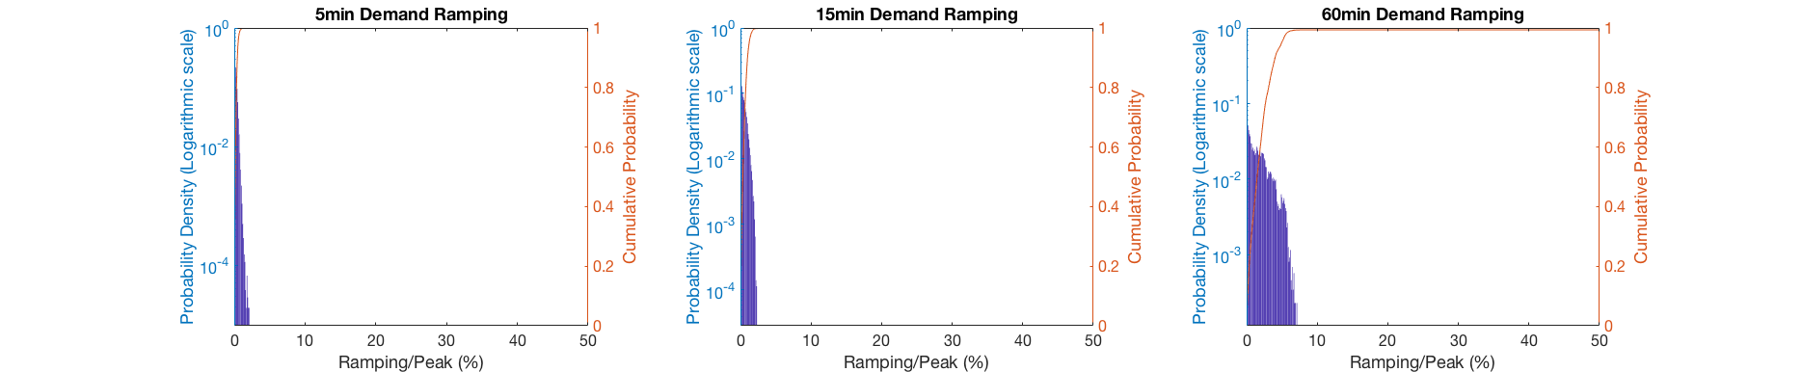

Demand5Ramping =

0.0060

Demand15Ramping =

0.0130

Demand60Ramping =

0.0501

* NetLoad

Netload is calculated base on the CAISO load portion with the scaled up renewables.

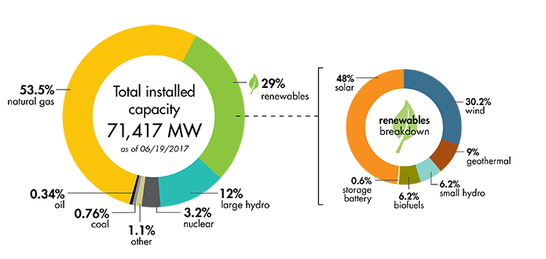

CAISO daily load peak around 30,000MW

71000 * 0.29 * 0.48 = 9883.2MW

CAISO estimated daily solar peak around 9900 MW

71000 * 0.29 * 0.30 = 6177MW

CAISO estimated daily wind peak around 6200 MW

Thus, the Netload results are here

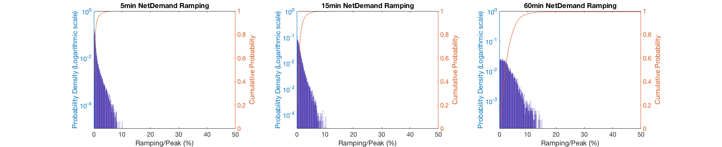

NetDemand5Ramping =

0.0170

NetDemand15Ramping =

0.0300

NetDemand60Ramping =

0.0771

**Using matlab to learn the relationship among Netdemand Ramping, total demand, solar, and wind. The linear model is applied.**

Setting renewable from 10% to 50% with difference value combination of solar and wind.

* 5min Netdemand Ramping - 0.006* total demand = 0.042* Solar capacity+ 0.0057* wind capacity – 50.458

Fitted status: (**red:** original, **blue:** fitted)

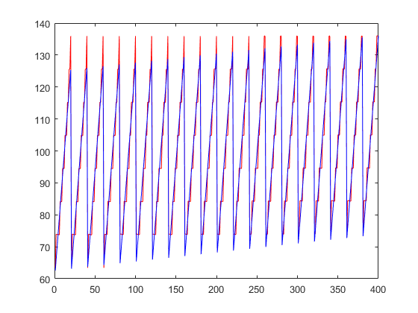

* 15min Netdemand Ramping - 0.013* total demand = + 0.072* Solar capacity+ 0.0183* wind capacity - 120

Fitted status: (**red:** original, **blue:** fitted)

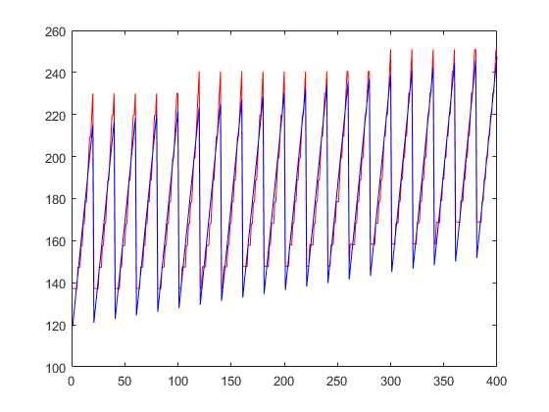

* 60min Netdemand Ramping - 0.0501* total demand = + 0.1576* Solar capacity+ 0.0591* wind capacity – 419.13

Fitted status: (**red:** original, **blue:** fitted)

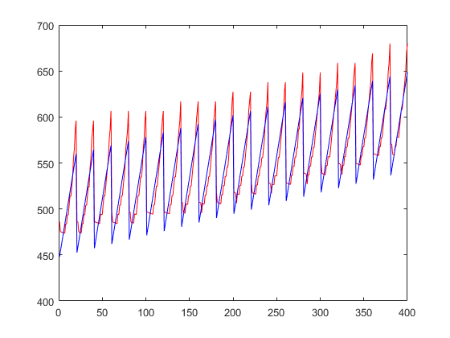

For the method of calculating the upper bond of the linear model

* **5 min upper bond**

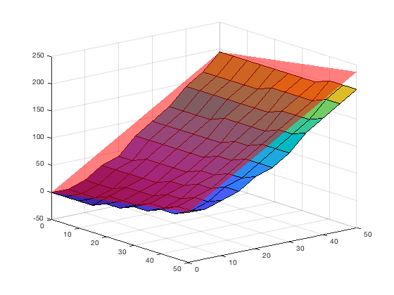

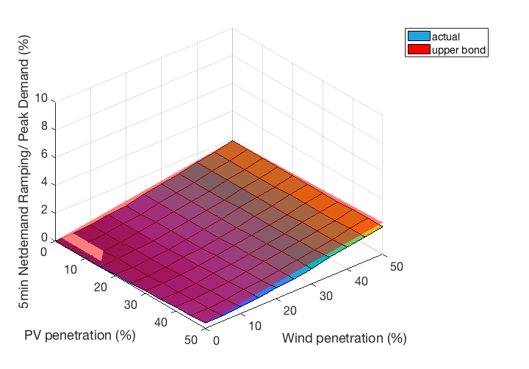

Netramping =

0.0060 * demand

0.0080 * PV

0.0639 * Wind

* **15min upper bond**

Netramping =

0.0130 * demand

0.0200 * PV

0.1823 * Wind

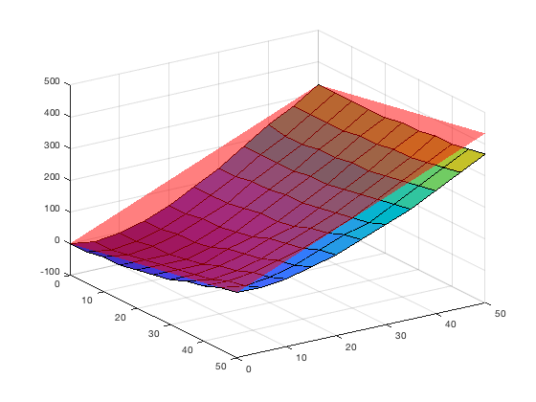

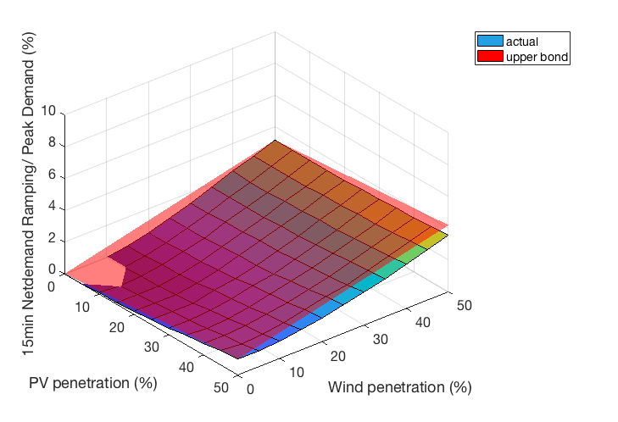

**- 60min upper bond**

Netramping =

0.0501 * demand

0.1290 * PV

0.0560 * Wind

